1

Two toy cars, red and blue, travel along a 2 metre track.

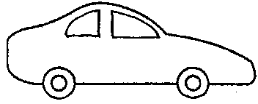
START
STOP
2 metres
red
blue
20 cm

The blue car has a 20cm start.
The two cars start at the same time.
The two cars reach the end of the track (the STOP mark) at the same time.

(a) Which car was faster?

Tick ONE box ()

❑ | The red car.
❑ | The blue car.
❑ | Both had the same speed.

(b) All of the following statements are correct. But which is the best explanation for the answer above?

Tick ONE box ()

❑ | Both cars started and stopped at the same time.
❑ | The red car travelled further than the blue car in the same time.
❑ | The blue car started ahead the red car.
❑ | Another reason: _______________________________________  _____________________________________________________

